**How to Install EViews 7 in Microsoft Window 10**

1. **Run the EViews7 setup.exe. And Click on “Install EViews” button.**



1. **Click on the “Next” button.**

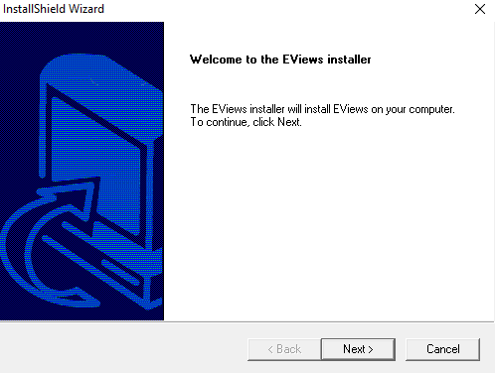

1. **Read License Agreement carefully and then Click on “Yes” button.**

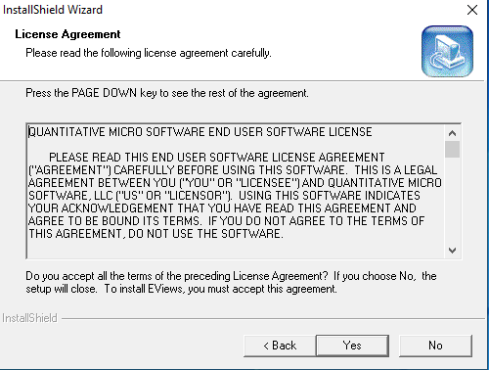

1. **Choose the Destination Location and Click on “Next” button.**

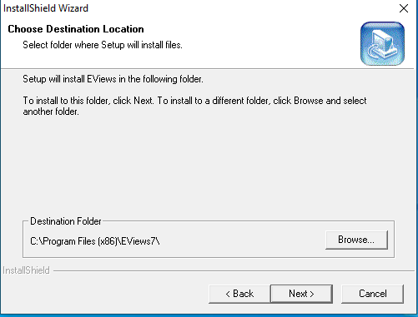

1. **Enter Serial Number and Click on “Next” button.**

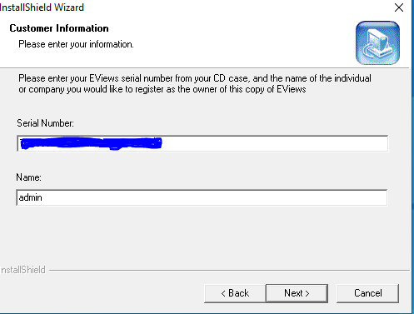

1. **Enter the cloning Key and Click on “Next” button**

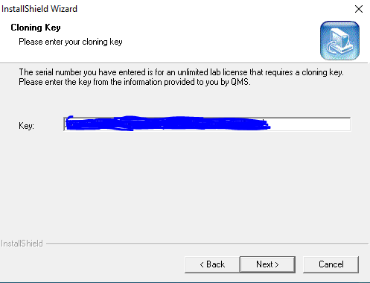

1. **Enter the License Server IP and Port Number. The License Server IP is “172.31.1.147”and Port No. is 25750.**

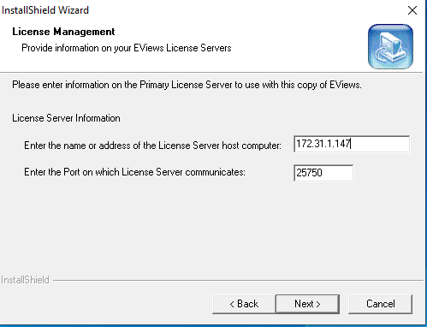

1. **Again enter License server IP & Port Number. Click on “Next” buton.**

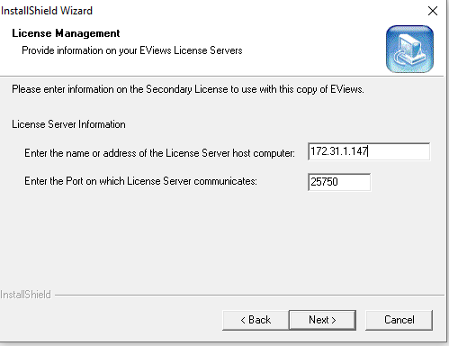

1. **Check “Select Components” and Click on the “Next” button.**

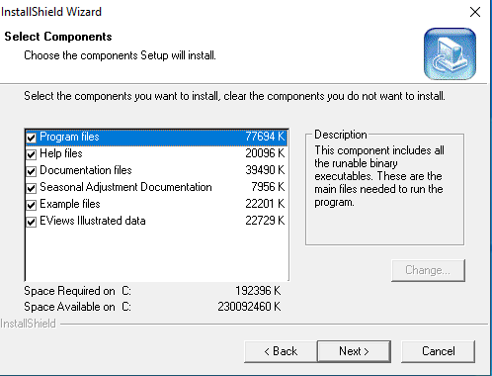

1. **Select Program Folder and Click on the “Next” Button.**

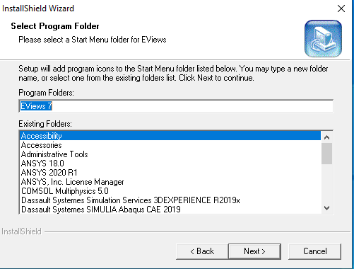

1. **To ask question .click on the “Yes”**

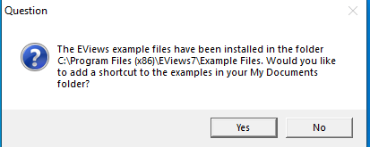

1. **To Ask Question “Would you like to create an icon for Eviews on your desktop” and Click on the “Yes” Button.**

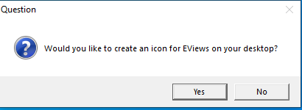

1. **Eview Successfully installed click on finish buton.**

